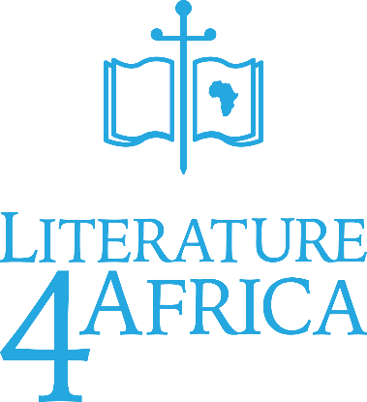

**DECEMBER 2022 – ANNUAL REPORT**

**What we’ve received**

This year we have received 3 separate Shipments from Eagles nest each consisting of 16+/- tonnes; total of 48 tonnes containing an estimated **18 725** Mixed Bibles; **16 992** Reading Books; **36 720** Adult Study Books; **12 920** Sunday School Packs For various ages spanning 1 to 18.

Here is a spreadsheet of everything we have received in 2022 Jan-November from Eagles Nest:



**What We’ve Distributed**

This year we distributed a Total of **28 277** Bibles including the ‘NKJV Paperback Bibles’, ‘Devotional CSB Bibles For Kids’, and the ‘Mixed Bibles’; **17 160** Reading Books; **6 286** CDs & DVDs; **35 000** Adults Study/ Discipleship Guides; **12 000** Sunday School Textbooks; **52 200** Gospel Booklets of John and Romans.

**Additions to L4A**

This Year for the first time I have set up an **Online Calendar** where people can book for an appointment by themselves, receive automated reminders & communicate via SMS; I also made our **first** **Website** from scratch where people can access further information, sign up for emails, view popular resources, online resources and access our online calendar to book for an appointment. These were done to help reach more people through internet searches, simplify booking, and record keeping. This year **601 appointments** **were made online**.

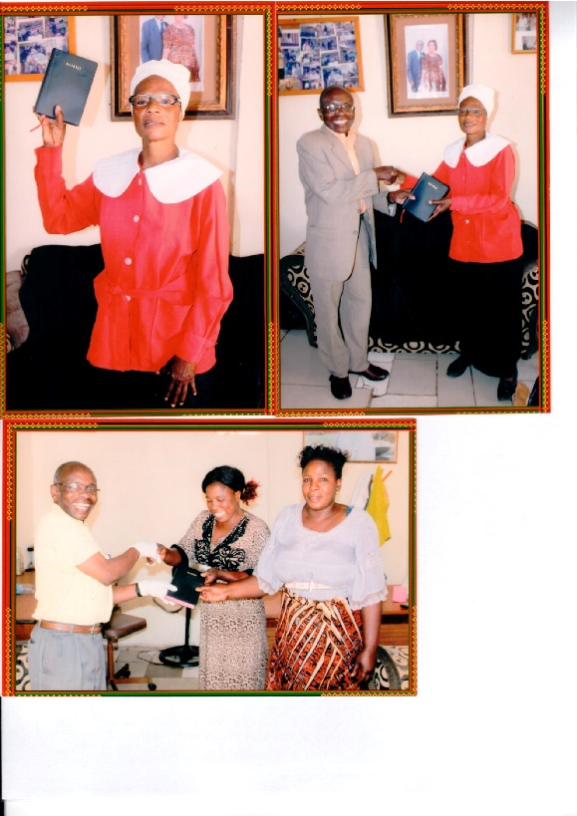**Collector’s Letters & Feedback**

CALVARY GREETINGS IN THE PRECIOUS NAME OF OUR LORD JESUS CHRIST WHO SAID" GO YE THEN THEIR FORE AND MAKE DISCIPLES...."-MATTHEW 28:19-20.

IT WAS GOOD THAT WE DISTRIBUTED THE HOLY BIBLES TO THE RECEIPIENTS IN THE FOLLOWING MANNER:

1.CHEWA HOLY BIBLES OF 20 TO PASTOR REUBEN MWALE OF KANAKANTAPA-CHONGWE DISTRICT AND EXTRA 8 BEMBA HOLY BIBLES.

2.CHEWA HOLY BIBLES OF 20 TO PASTOR BANDA OF CHIPATA DISTRICT AND EXTRA OF 8 BEMBA HOLY BIBLES.

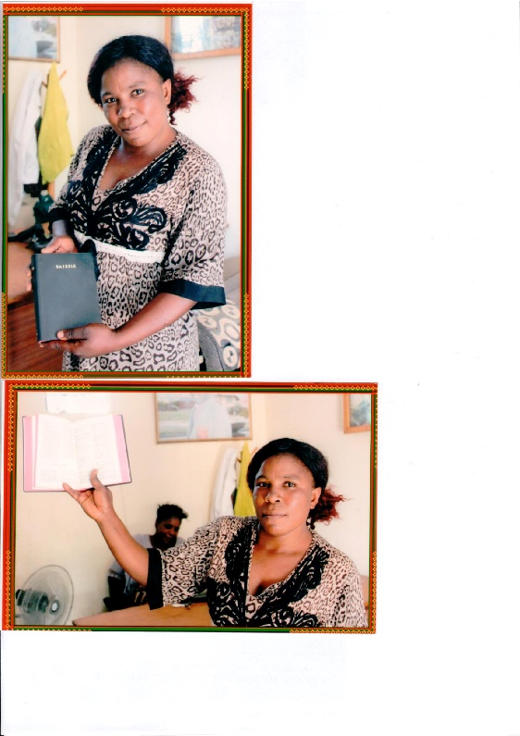3.CHEWA HOLY BIBLES OF 20 STOCKED BY WBEA FOR ITS LOCAL DISTRIBUTIONS AND 8 BEMBA HOLY BIBLES.

TOTAL CHEWA HOLY BIBLES DISTRIBUTED ACCORDINGLY IS 60 AND 24 BEMBA HOLY BIBLES.

HAD TO TOP UP FROM THE CHANGE TO GET AN EXTRA COPY OF THE BIBLE FOR MY OFFICE LIBRARY.

THE DELIVERY WAS DELAYED BY THE BIBLE SOCIETY OF ZAMBIA TO WBEA. HAD TO COLLECT THE HOLY BIBLES ON THE 28TH SEPTEMBER,2020 WITH THANKS.

THE TWENTY IN STOCK WILL BE DISTRIBUTED THE NEXT SUNDAY AND THE REPORT WILL FOLLLOW ACCORDINGLY.

**Yours Bishop Bwanali G, Billy Phiri**

**Evangelist/ Missionary.**

To whom it may concern

I Mr Mkatshane, leader of body of Christ in delft, cape town, hereby passes my thanks and appreciation of reading material I got from you, it's a very equipping literature.

Thank you very much and God bless everyone who has made this possible. When have time will make an appointment with you to meet in your office,

Yours faithfully **Pastor Mkatshane**

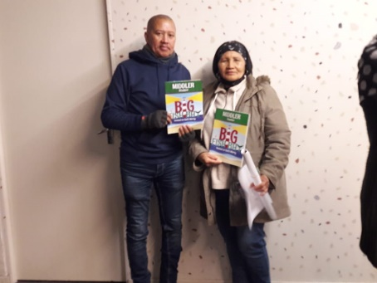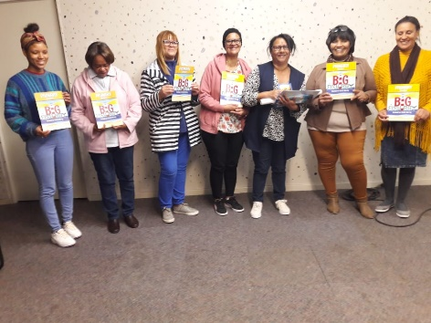Thank you very much for the literature.

25 teachers have been equipped to reach kids.

9 of them will be starting Kids clubs in their community

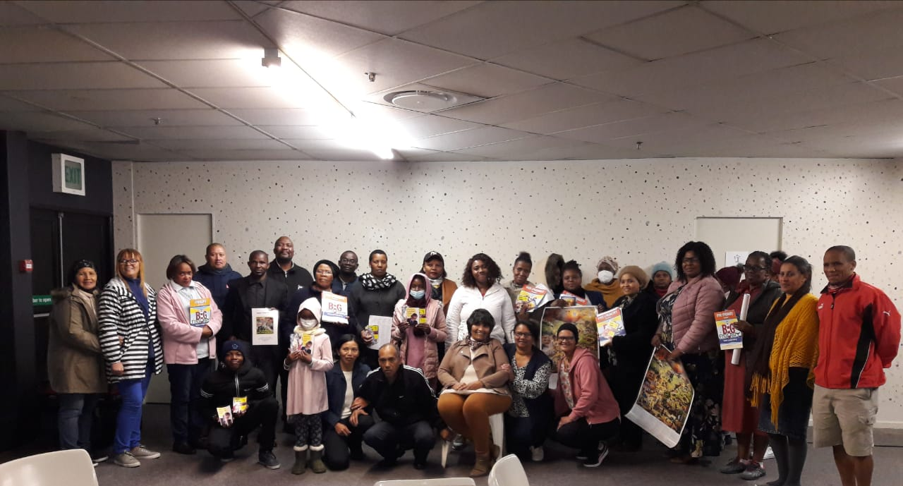God bless you

PS: Apologise for the quality of the photos

**- Willie & Tina de Klerk**

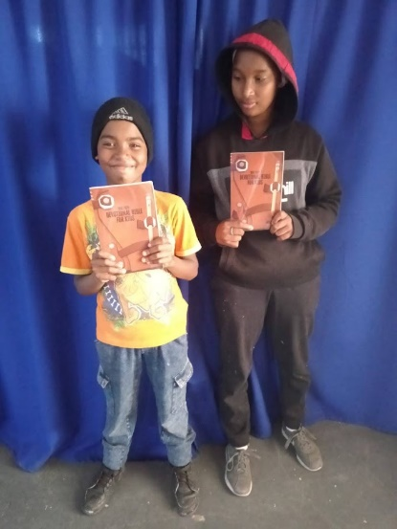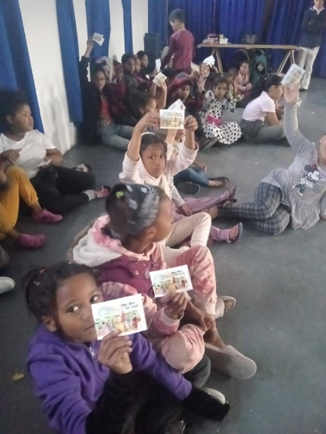

Good day

Herewith a heartfelt thank you and appreciation for the Bibles and resources received that was distributed and disseminated within the community.

We had a school holiday programme and utilised the opportunity to spread the Gospel amongst the youth and Sunday School.

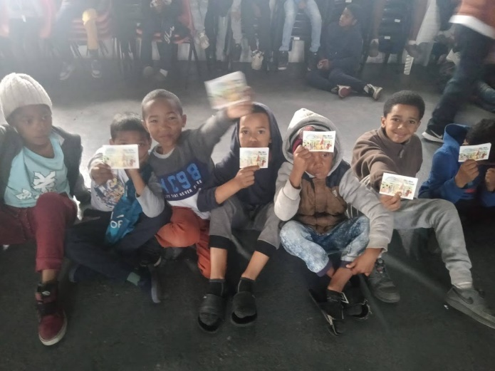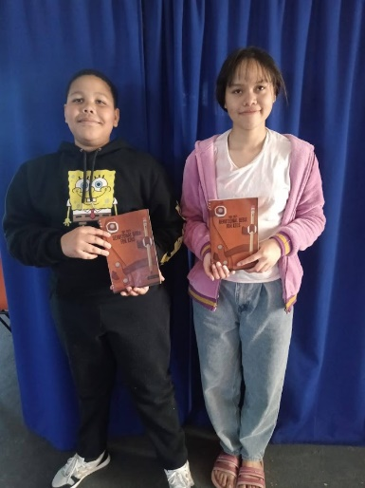Thank you for enabling us to reach out to those in dire need to hear the Word of God and to be equipped with the knowledge of the Word and of Jesus Christ.

Kind Regards

Yours in Christ

**- Pastor Marilyn Jones**

I, Nwabisa Mbana, The Secretary of Children's Ministry Interim Committee, under the Leadership of Rev. Sikupela, Steward Mr Mampofu and All our Circuit Management, would like to pass some words of appreciation to Literature for Africa for the Donation of English Bibles, that you have donated to our Circuit Ministry.  It has been a great opportunity and excitement as we are working with children and teenagers from the disadvantaged areas in Khayelitsha & Mitchells Plain, where some parents struggle to buy them Bibles & Hymn books. Steward Mampofu has given us the Bibles and Children are very excited.

We would like to thank you for this donation. The bibles will have a positive impact in our Circuit Ministry.

Thank you once again.

Mrs N. Mbana

**- Rev. A. Moukena**

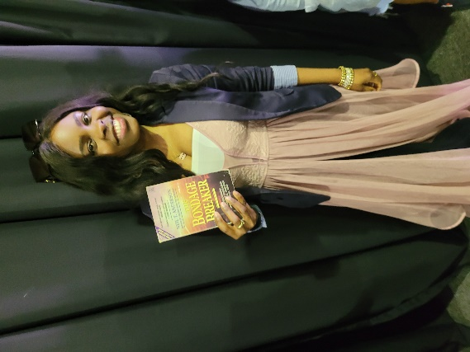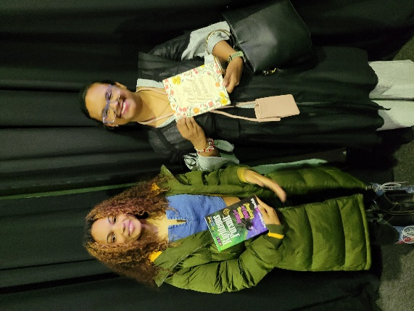

Hi Ray

Here is a few pics of the resources that some of the ladies received.

Thank you they lives would be change through this.

Thank you so much for your generous gift of the books.

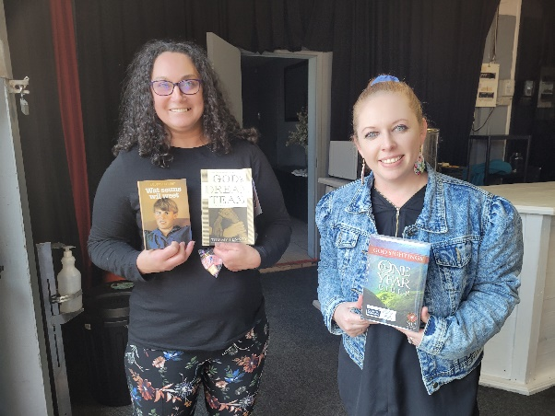Have a blessed day.

Kind Regards

**- Nadine**

Thank you for the Bible study books

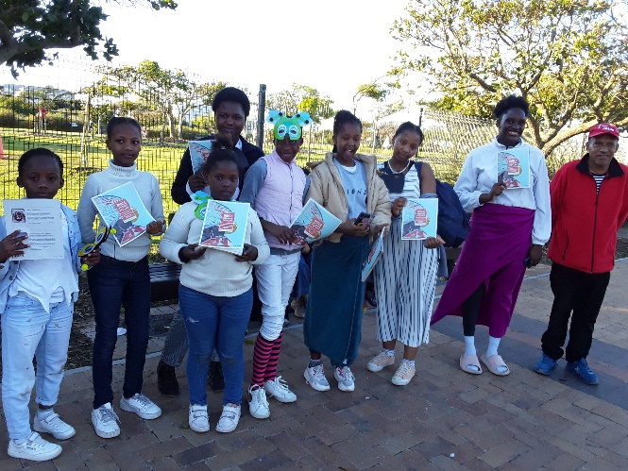We handed them to Kids club in Khayelitsha during our outing in Greenpoint.

From 3eministry - Evangelize-Educate-Equip

God bless you

**- Willie & tina**

Good afternoon, Ray

We hereby wish to express our sincere gratitude to Literature for Africa for your

generous donation of the 2022 Daily Bible Meditations that we presented as gifts

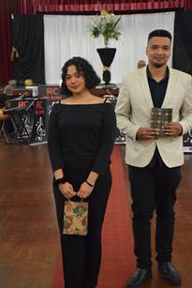to all those who served our guests at our Autism Awareness Dinner on Saturday, 13 August 2022.

*Joshua Alexander and Zara Cloete*

*holding the gift bags containing the*

*Devotional Books donated by*

*Literature 4 Africa.*

May the Lord continue to bless you abundantly.

Kind regards

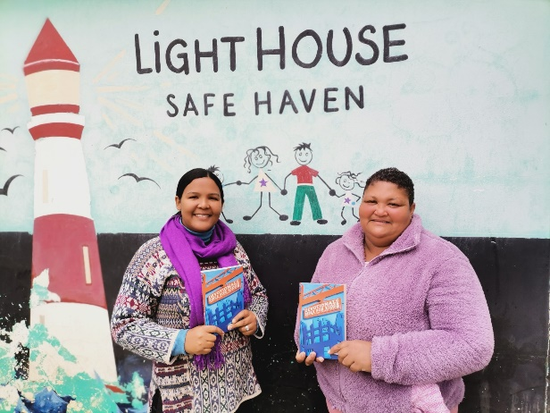**- Benita Alard**

Thank you once again for the seed of bibles sown into this area in Africa. Tulbagh received second hand and brand new English bibles this past week (end of August 2022)

They have been shared out amongst the community.

* Lighthouse Safe Haven
* Gracious Dance Ministry
* Jesus Nation cell group
* 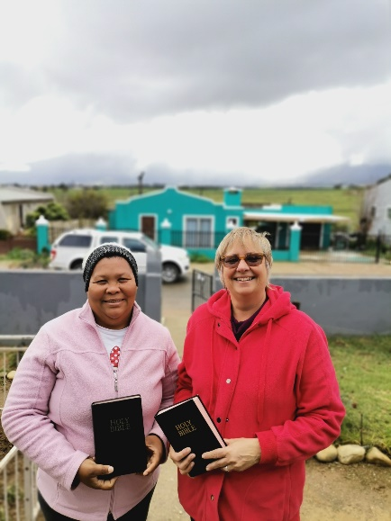Inter church Prayer group

I have the opportunity to collect for the area

From CAPE TOWN

It with great pleasure I do the trip to collect because I know how welcoming and needed the bibles are here.

Being an Afrikaans language speaking area firstly – I was pleasantly surprised to hear of the need for English too.

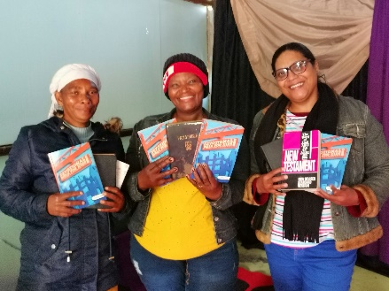The Gracious ministry were praying for the members to go deeper in the Word and to start studying the Word in another language. *Just a few days later their prayers were answered.* They have copies of the bibles for each member so they can get going together reading the Word in English.

The Jesus Nation cell group who has been growing in doing their services on a Sunday in different languages were blessed with the delivery of bibles. Their translator was so excited to have the English bibles to give out, she burst out in song and praise for God their request.

Between the safe haven and the prayer group many will be receiving bibles who have for a long time wanted to study the Word in English, their second language. God is definitely on the move as we go deeper into His Word.

He knows our needs and meets us faithfully at our point of need.

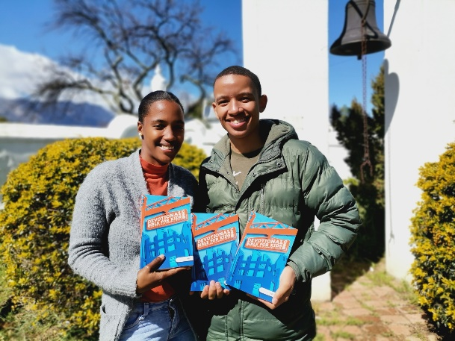The devotionals like Daily bread and Open window are also a blessing as the groups go out to the community and farms in the area.

Once again thank you to the sponsors and those that work hard in the sorting dept.

I look forward to visiting again, it is a great blessing to receive literature 4 Africa,

Regards

**- Belinda Weber**

Volunteer in Tulbagh

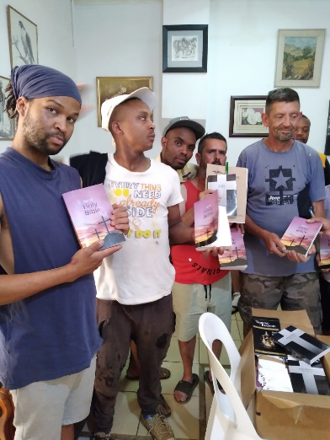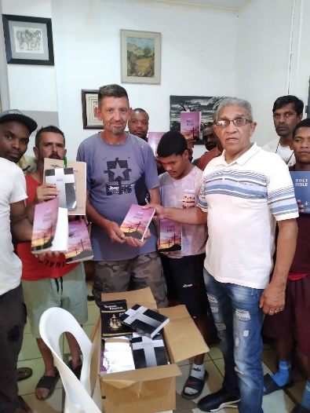

Greetings in Jesus Name

Kindly receive the pictures and testimony.

Past Reggie Singh, distribute NKJV Bibles and some study materials to some of the people at the drug rehabilitation centre in Lenasia, South of Johannesburg.

They have a ministry that side, Father's House Ministries.

Each Sunday they minister to over 100 people.

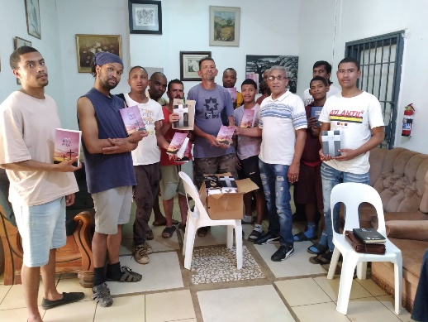I would like to thank you for your assistance with Bibles and outreach material.

God bless

**- Richard Jaars**

**Picture Gallery**

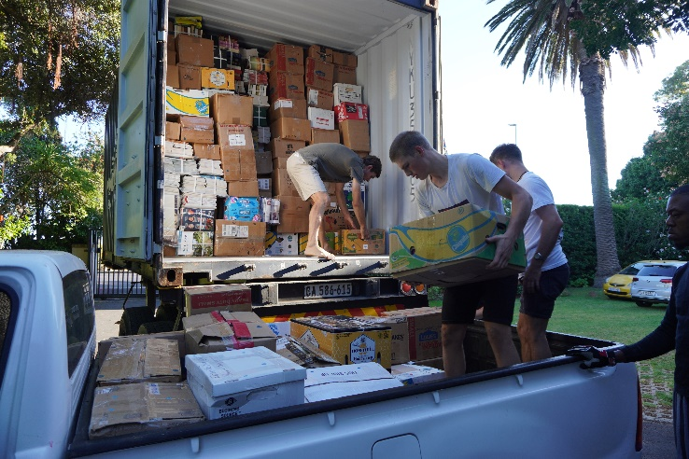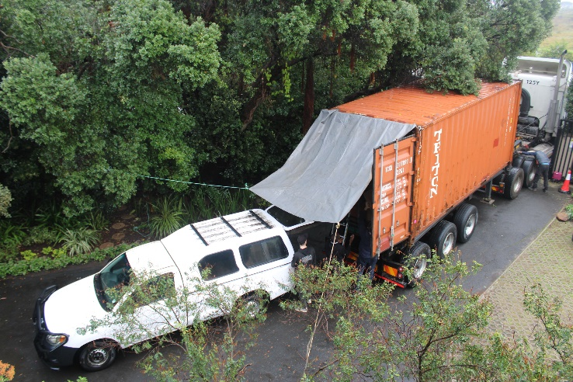**Container Offloads Dec 2021-Nov 2022**

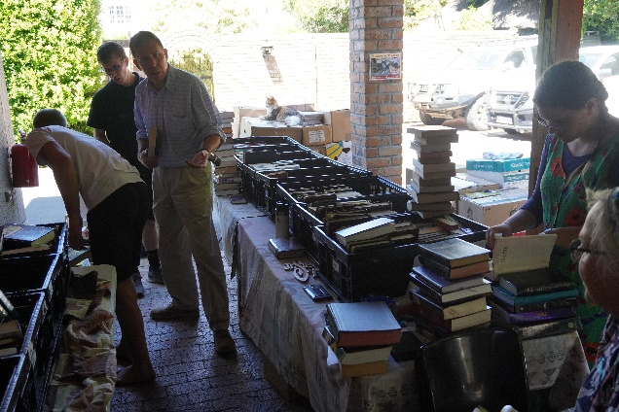**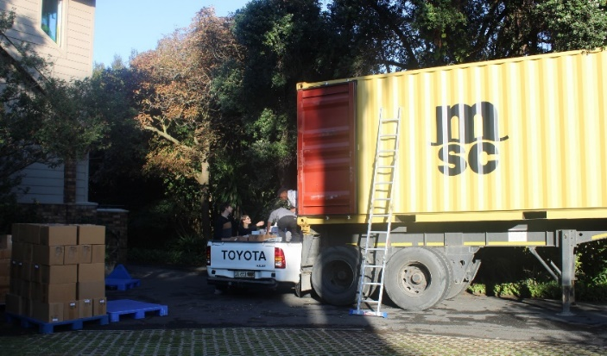 22 February 2022 14 July 2022**

**15 August 2022 Bible Sorting**

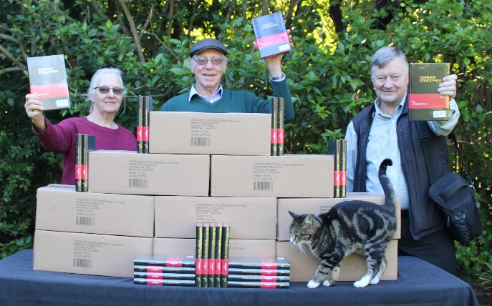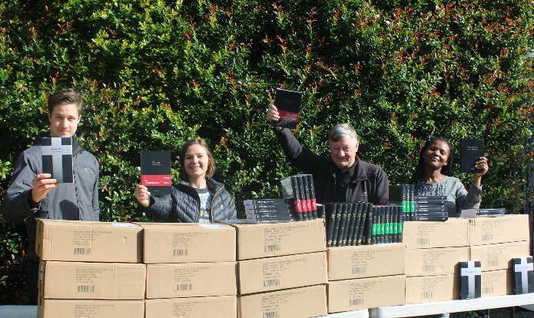**Special Projects Bibles**

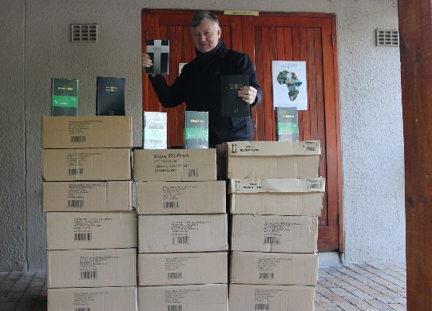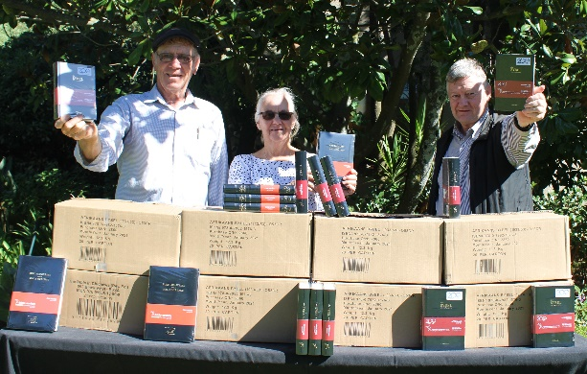

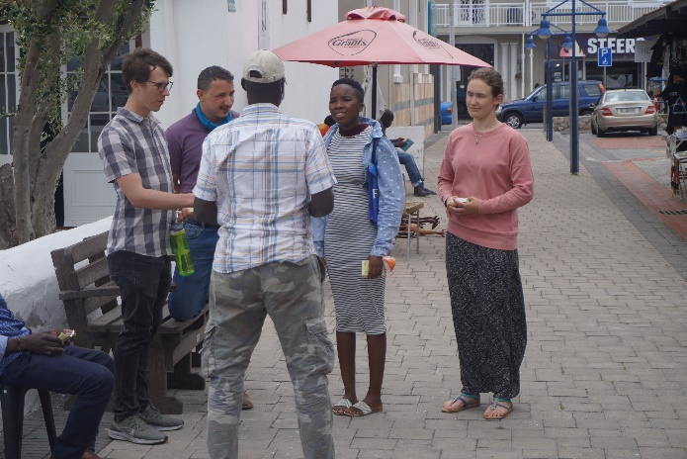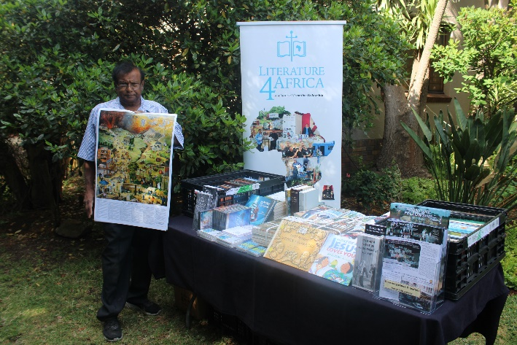**Events**

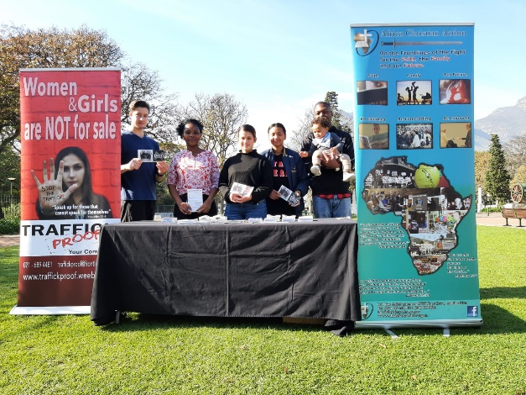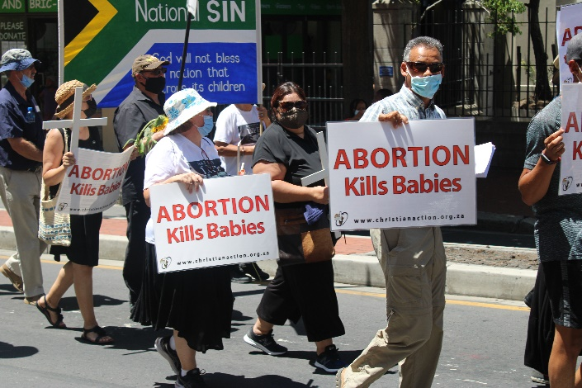 **Home Education Day Fair Biblical Worldview Summit**

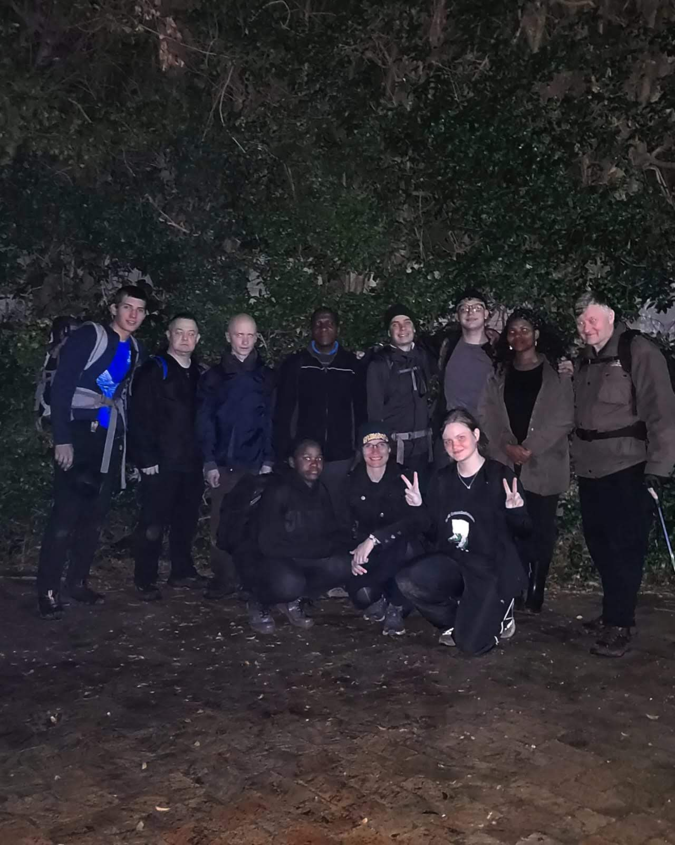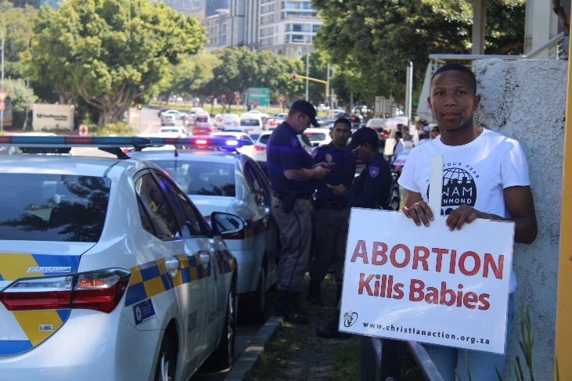 **March For Life Women’s Day**

**Life Chain**

**Great Commission Course**